INSTALLATION AND PREPARATION

- Install XAMPP in your device:
https://www.apachefriends.org/download.html

- Locate the htdocs folder:
C:\xampp\htdocs

- Put the following folders inside htdocs:
- Admin Online Computer Store
- Online Computer Store
- Image

- Set up database:
- Start XAMPP Apache and MySQL module
- Enter phpMyAdmin by clicking MySQL's Admin button
- Create a new database named computer_store
- Inside the database, click import
- Import computer_store.sql
SELF-SIGNED DIGITAL CERTIFICATE

- Open this file (need a notepad with administrator’s permission):
C:\Windows\System32\drivers\etc\hosts.ics

- Add this code into the file:
127.0.0.1 localkahtech.com
127.0.0.1 admin.localkahtech.com

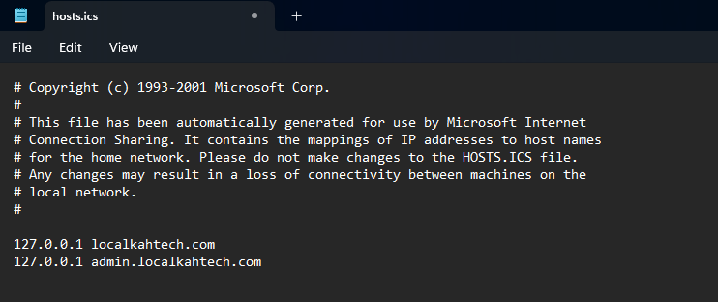

- Open this file (open with a notepad / code editor):
C:\xampp\apache\makecert.bat

- Modify this code in the file:
Change:
bin\openssl x509 -in server.csr -out server.crt -req -signkey server.key -days 365

To:
bin\openssl x509 -in server.csr -out server.crt -req -signkey server.key -days 365 -extfile v3.ext

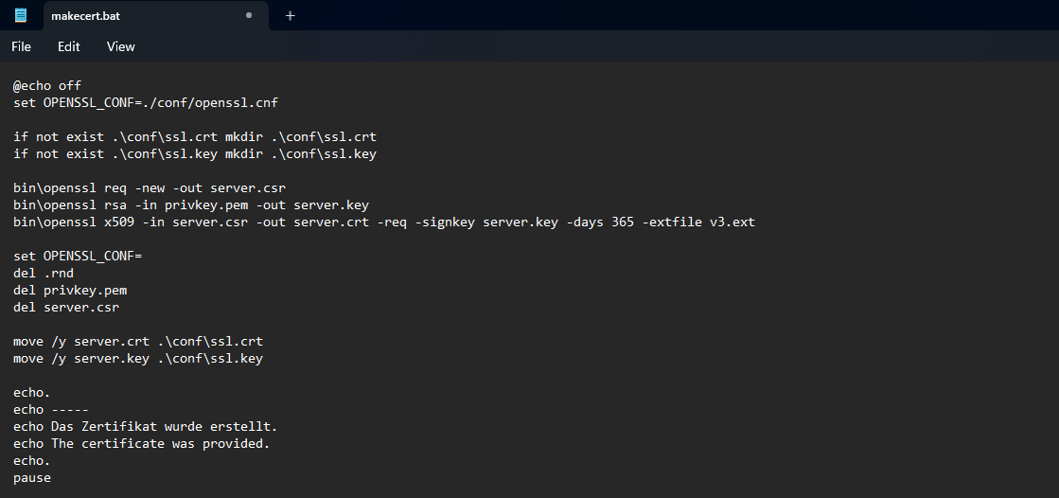

- Create a new v3.ext file (same folder with makecert.bat):
C:\xampp\apache\v3.ext

- Add this code into the file:
authorityKeyIdentifier = keyid, issuer
basicConstraints = CA:FALSE
keyUsage = digitalSignature, nonRepudiation, keyEncipherment, dataEncipherment
subjectAltName = @alt_names
[alt_names]
DNS.1 = localhost
DNS.2 = *.localkahtech.com
DNS.3 = localkahtech.com
DNS.4 = 127.0.0.1
DNS.5 = 127.0.0.2

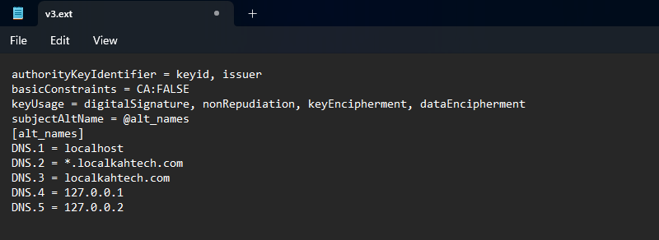

- Run this file (double click to run):
C:\xampp\apache\makecert.bat

- Fill in details:
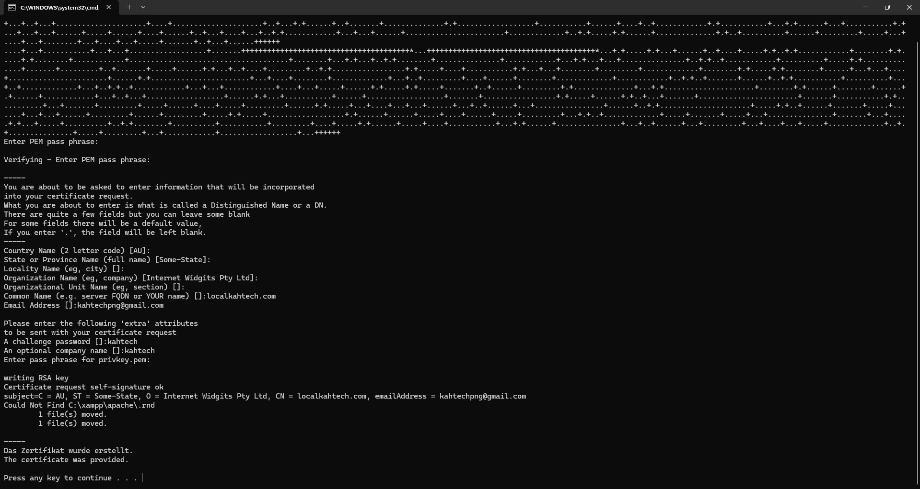
- PEM pass phrase: kahtech
- Verifying PEM pass phrase: kahtech
** Take note: it is normal that the input is hidden

- First 5 rows leave empty to use the default value
- Common name: localkahtech.com
- Email address: kahtechpng@gmail.com
** Take note: the email address is just an example, it can be changed to any valid email address

- Challenge password: kahtech
- Optional company name: kahtech
- Pass phrase for privkey.pem: kahtech

- Run this file (double click to run):
C:\xampp\apache\conf\ssl.crt\server.crt

- Install certificate:
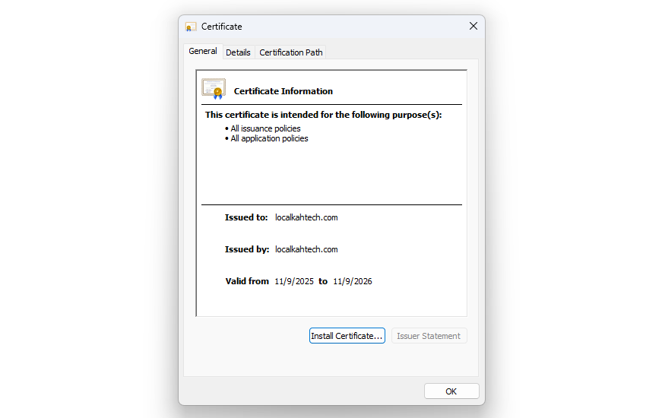
- Click < Install Certificate >

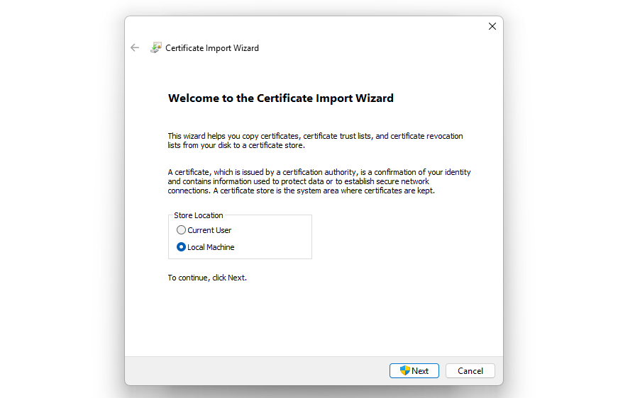
- Choose < Local Machine >
- Click < Next >
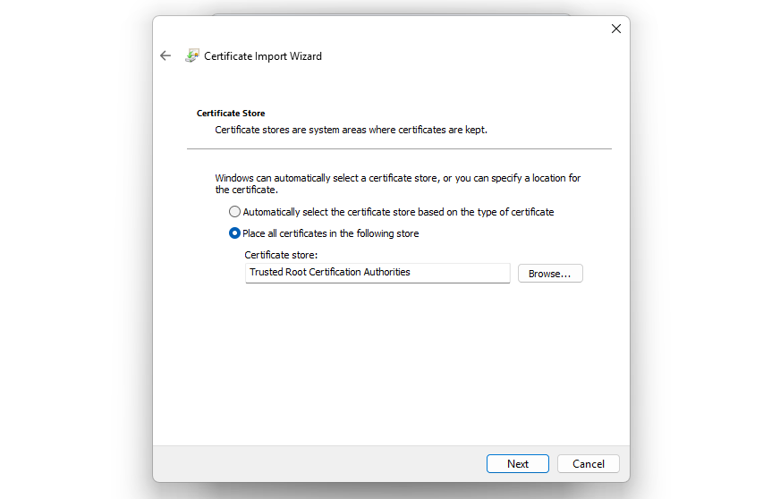
- Choose < Place all certificates in the following store >
- Click < Browse… >
- Choose < Trusted Root Certification Authorities >
- Click < Next >

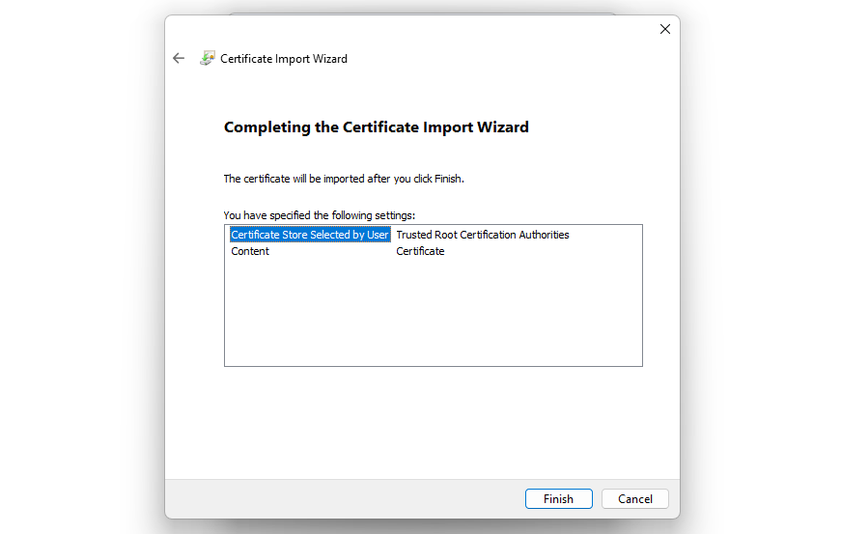
- Click < Finish >

- Open this file (open with a notepad / code editor):
C:\xampp\apache\conf\httpd.conf

- Make sure these lines are not comments:
- LoadModule ssl_module modules/mod_ssl.so
- Include conf/extra/httpd-ssl.conf
** Take note: remove the # to uncomment the line

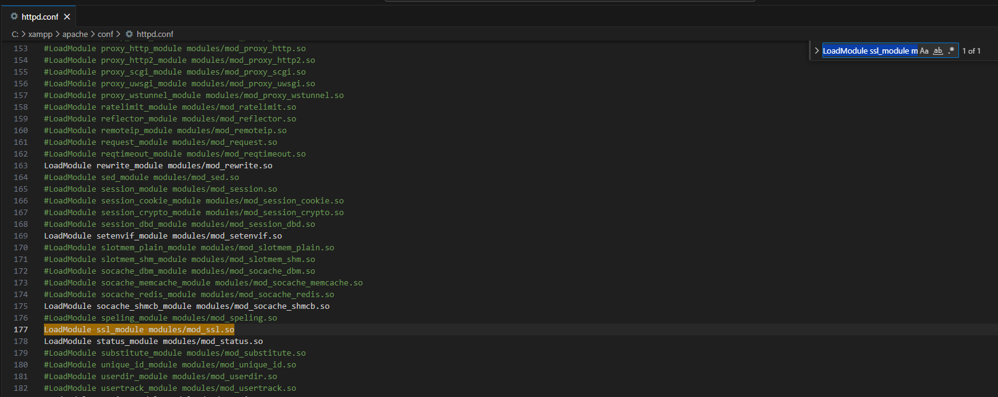

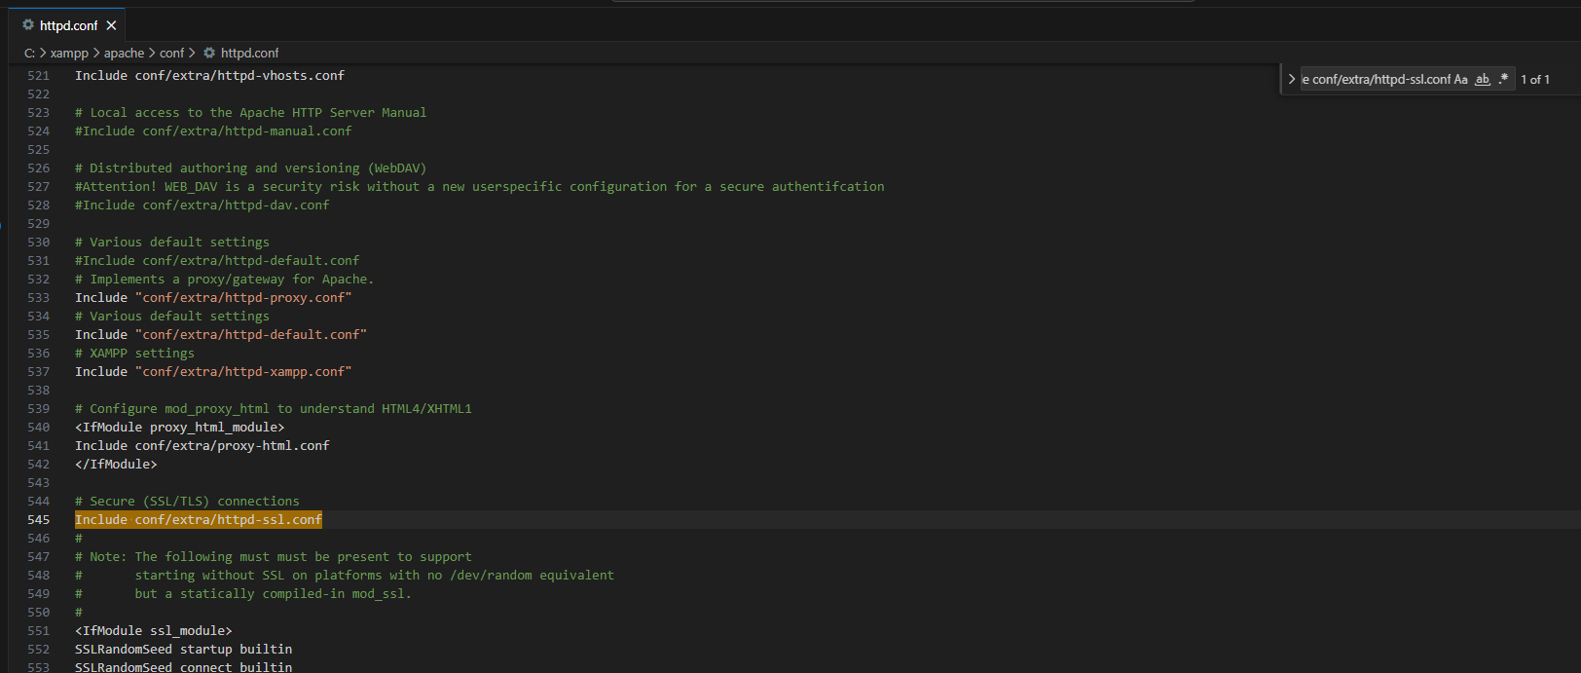

- Open this file (open with a notepad / code editor):
C:\xampp\apache\conf\extra\httpd-vhosts.conf

- Add this code into the file:
<VirtualHost *:80>
ServerName localhost
DocumentRoot "C:/xampp/htdocs"
<Directory "C:/xampp/htdocs">
AllowOverride All
Require all granted
</Directory>
</VirtualHost>

<VirtualHost *:80>
ServerName www.localkahtech.com
ServerAlias localkahtech.com
DocumentRoot "C:/xampp/htdocs/Online Computer Store"

Alias /Image "C:/xampp/htdocs/Image"

<Directory "C:/xampp/htdocs/Image">
Options Indexes FollowSymLinks
AllowOverride All
Require all granted
</Directory>

RewriteEngine on
RewriteCond %{SERVER_NAME} =www.localkahtech.com [OR]
RewriteCond %{SERVER_NAME} =localkahtech.com
RewriteRule ^ https://%{SERVER_NAME}%{REQUEST_URI} [END,NE,R=permanent]
</VirtualHost>

<VirtualHost *:443>
ServerName www.localkahtech.com
ServerAlias localkahtech.com
DocumentRoot "C:/xampp/htdocs/Online Computer Store"

Alias /Image "C:/xampp/htdocs/Image"

<Directory "C:/xampp/htdocs/Image">
Options Indexes FollowSymLinks
AllowOverride All
Require all granted
</Directory>

SSLEngine on
SSLCertificateFile "conf/ssl.crt/server.crt"
SSLCertificateKeyFile "conf/ssl.key/server.key"

Header always set Strict-Transport-Security "max-age=31536000"
</VirtualHost>

<VirtualHost *:80>
ServerName www.admin.localkahtech.com
ServerAlias admin.localkahtech.com
DocumentRoot "C:/xampp/htdocs/Admin Online Computer Store"

Alias /Image "C:/xampp/htdocs/Image"

<Directory "C:/xampp/htdocs/Image">
Options Indexes FollowSymLinks
AllowOverride All
Require all granted
</Directory>

RewriteEngine on
RewriteCond %{SERVER_NAME} =www.admin.localkahtech.com [OR]
RewriteCond %{SERVER_NAME} =admin.localkahtech.com
RewriteRule ^ https://%{SERVER_NAME}%{REQUEST_URI} [END,NE,R=permanent]
</VirtualHost>

<VirtualHost *:443>
ServerName www.admin.localkahtech.com
ServerAlias admin.localkahtech.com
DocumentRoot "C:/xampp/htdocs/Admin Online Computer Store"

Alias /Image "C:/xampp/htdocs/Image"

<Directory "C:/xampp/htdocs/Image">
Options Indexes FollowSymLinks
AllowOverride All
Require all granted
</Directory>

SSLEngine on
SSLCertificateFile "conf/ssl.crt/server.crt"
SSLCertificateKeyFile "conf/ssl.key/server.key"

Header always set Strict-Transport-Security "max-age=31536000"
</VirtualHost>

** Take note: the folder path can be different, ensure they match the actual path of your folders

- YouTube references:
https://www.youtube.com/watch?v=leAFGFhE8O8
https://www.youtube.com/watch?v=eqrDHkIFe8U

SUPPRESSING ERRORS CONFIGURATION

- Open this file (open with a notepad / code editor):
C:\xampp\apache\conf\httpd.conf

- Add this code below LogLevel warn:
ServerTokens Prod

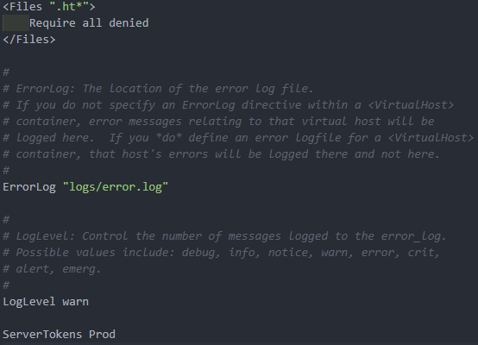
- Open this file (open with a notepad / code editor):
C:\xampp\apache\conf\extra\httpd-vhosts.conf

- Add these lines to both localkahtech.com and admin.localkahtech.com:
ServerSignature Off
ErrorDocument 404 /errors/404.php
ErrorDocument 500 /errors/500.php

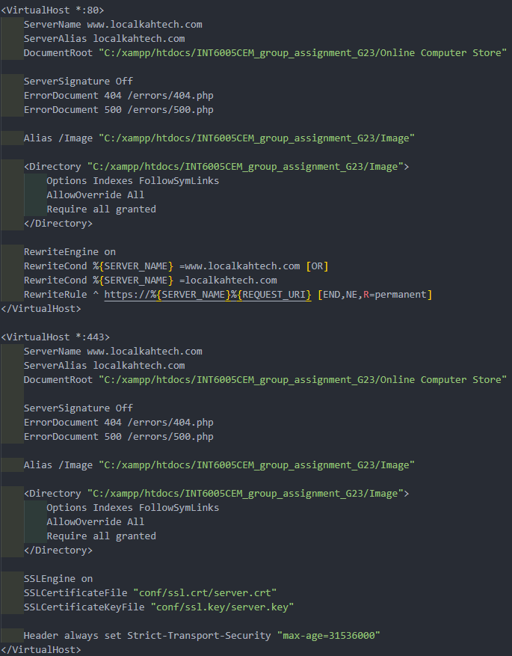
- Open this file (open with a notepad / code editor):
C:\xampp\php\php.ini

- Modify this code in the file:
Change:
display_errors=On
display_startup_errors=On
log_errors=On

To:
display_errors=Off
display_startup_errors=Off
log_errors=On

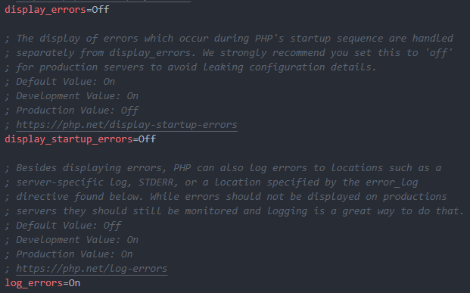

- Check files:
Make sure you have 404.php and 500.php inside your errors folder for both user and admin

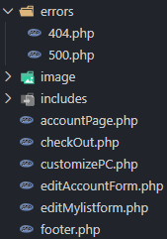

EMAIL VERIFICATION

- Open this file (open with a notepad / code editor):
C:\xampp\php\php.ini

- Add this code into the file:
[mail function]
For Win32 only.
http://php.net/smtp
SMTP=smtp.gmail.com
http://php.net/smtp-port
smtp_port=587
sendmail_from = your_email_address_here
sendmail_path = "\"C:\xampp\sendmail\sendmail.exe\" -t"

** Take note: this code must be added below [mail function]

- Open this file (open with a notepad / code editor):
C:\xampp\sendmail\sendmail.ini

- Add this code into the file:
[sendmail]
smtp_server=smtp.gmail.com
smtp_port=587
error_logfile=error.log
debug_logfile=debug.log
auth_username=your_email_address_here
auth_password=your_password_here
force_sender=your_email_address_here (it's optional)

** Take note: this code must be added below [sendmail]

- Email address and password
For the previous steps, you are required to provide your email address. All the OTP verification emails will be sent using the email address you provided.

** Take note: the auth_password in step no.4 is not your actual email address password, please follow the steps below to get the auth_password

- Go to your Google Account
- Click < Security & Sign-in >
- Click < 2-Step Verification >
- Click < App Passwords >
- Create your app password
- You will get a 16-character app password, use it as your auth_password

** Take note: don’t share the auth_password to anyone to protect your google account.

- Website references:
https://www.codingnepalweb.com/configure-xampp-to-send-mail-from-localhost/
VISIT THE WEBSITE

- Visit the website:
- Start XAMPP Apache and MySQL module
- Open any browser (Google Chrome and Microsoft Edge are recommended)
- Use the link to visit the user website:
https://localkahtech.com/
- Use the link to visit the admin / manager website:
https://admin.localkahtech.com/

** Take note: if your XAMPP is running, please restart it after you configure all the files

